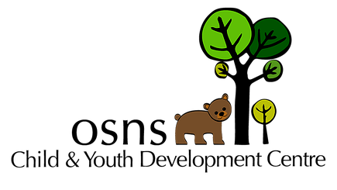
Infant Development Program Supported Child Development Infant Development Program

South Okanagan and Similkameen Early Childhood Services
Phone: 250-492-0295 Fax: 250-492-2164 Email: maryland.fiume@osns.org
Mail: #103-550 Carmi Avenue, Penticton, BC V2A 3G6
Referral Form
Date of referral: | Referral source:  Contact #: |  |  |  |  | Is this an urgent referral (for medical professional use only):  - Yes  - No
Child’s full name: |  |  |  | - Male  - Female |  |  |  | Birth date:
Parent/foster parent/guardian names and contact information. Please include first and last names and put an “*” beside best method for contact (e.g. phone, cell phone, email)
Names: |  | Relationship to child: |  | Phone: (H=home; C=cell) |  |  | Email: |  | Legal guardian: Yes or No
1.
2.
3.
Child’s street address (including city): |  |  | Child’s mailing address, if different than street (including postal code):
Primary language(s): |  | Cultural Background (optional) |  |  |  |  |  | Translator required:  - Yes  - No
Please explain reason for referral (attach any relevant reports):

Family physician/pediatrician: |  |  |  |  | Other service providers:
Social worker’s name (if involved with MCFD): |  |  |  |  | Phone #:

I, , legal guardian of the above-named child, consent to this referral and authorize the South Okanagan/Similkameen Early Childhood Services Group (comprised of the Infant Development Programs, Child and Youth Development Centre, Supported Child Development Program and Interior Health’s Speech-Language Department) to share information, collaborate and participate as members to screen and initiate an action plan for my child.

Signature of parent/guardian: Date:

Please note: Signing this consent is voluntary and you may withdraw your consent at any time. This consent will be in effect for one year from the date of your signature. October 2018

